

Search

David Murphy

01 August [Development](https://messapps.com/tag/development/)

**Creating Your First iOS Developer Account**

***NOTE:*** Creating an iOS Developer Account costs approximately $99.00 USD

**Creating an Apple Developer account is really simple**

What’s not, however, is creating an entire app from scratch. Typically, one's curiosity about the mystery of coding will linger, even if they plan to delegate a team to develop the app. This guide will walk you through all the steps of creating an Apple ID and Development account so that you can gain access to your very own programming control­room (Xcode).

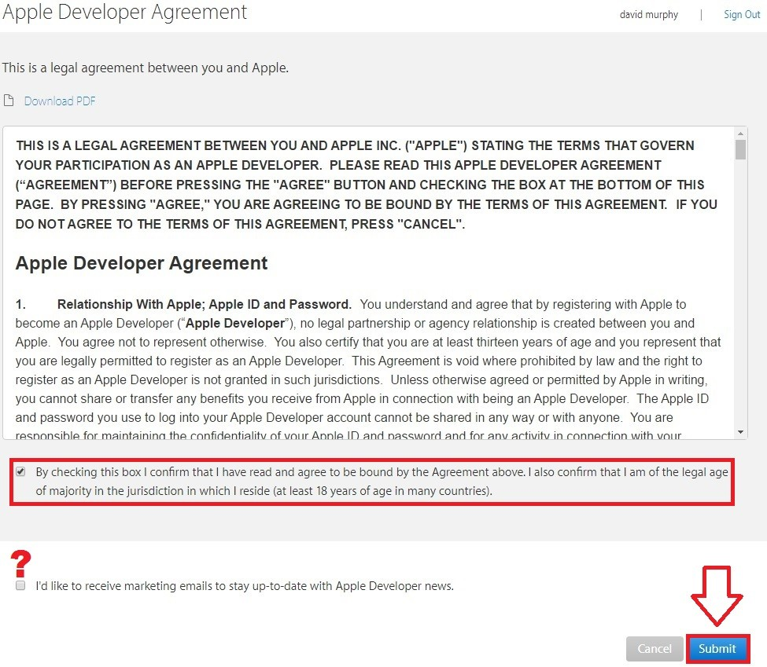

Begin by visiting apple’s website here: [**https://developer.apple.com/enroll/**](https://developer.apple.com/enroll/)**.** If you haven’t already, **Create an Apple ID**

or **Sign­in** with an existing one; you may need to re­click the URL provided above after the account creation process if you're not already reverted back to the installation page upon account creation. Next, you’ll need to choose between registering your account as an **Individual Business** or as a **Company/Organization** ­ and yes, it matters which one you select:

**Individual/Sole Proprietor/Single Person Business:** For individuals or companies that are not an officially recognized business; your account can only be accessed through a single login. This is most useful for freelance developers who are barely starting out or won’t need to include other users on their account.

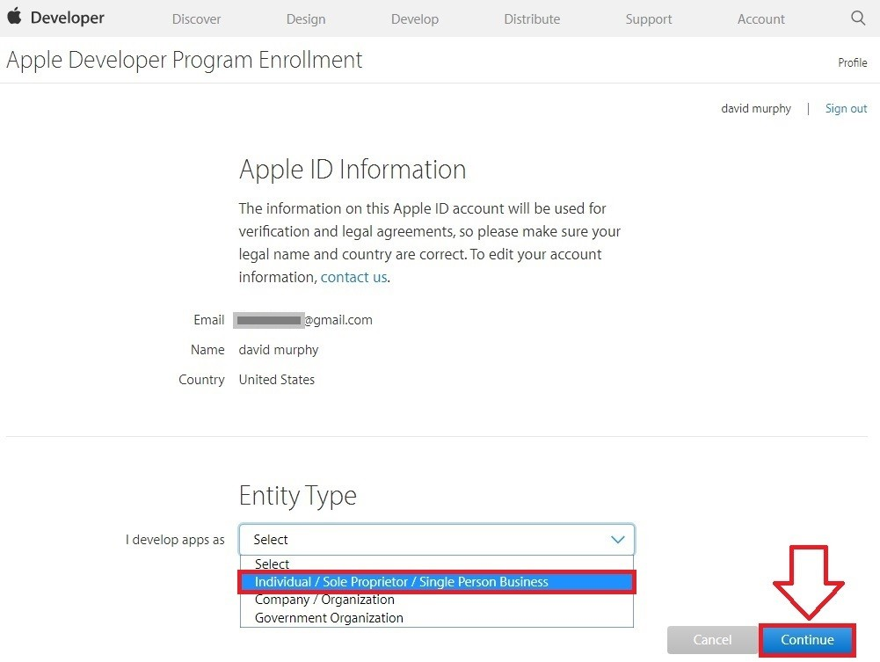

**Company/Organization:** This will allow more than one user login to be linked together, authorizing the primary owner with the power to regulate the extent of each team member's permissions. A D­U­N­S Number and confirmation for having the legal authority as or granted by the organization’s owner/founder to register the organization’s Apple ID must be given in order to proceed as a **Company/Organization**. Check [**Here**](https://developer.apple.com/program/enroll/dunsLookupForm.action) to confirm whether or not your company is recognized by Apple as being a

legal entity

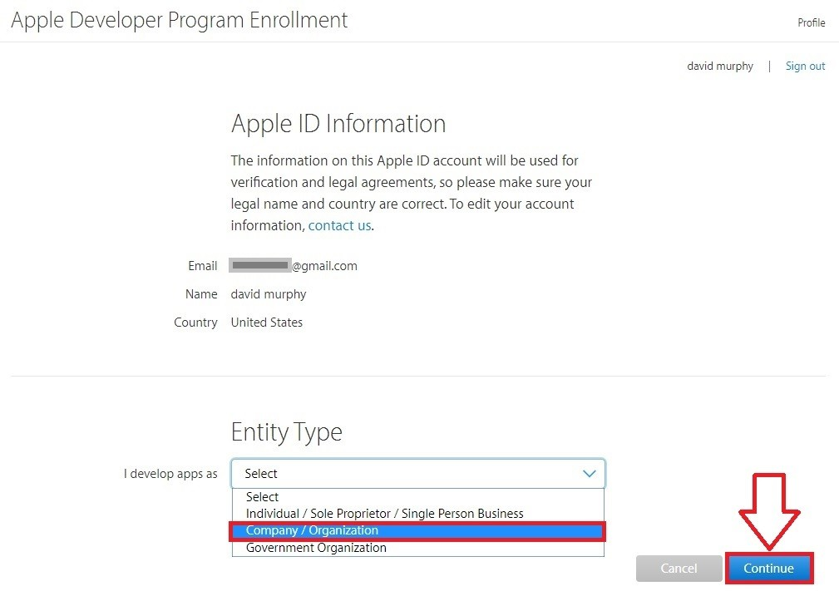

The requirements page will appear as it's show in the image below:

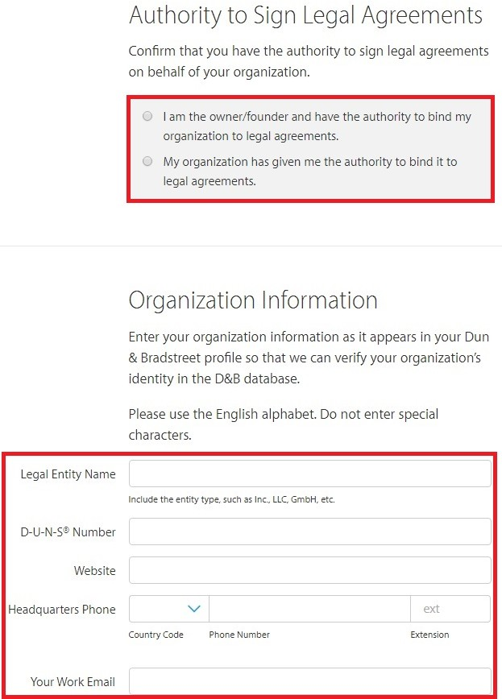

After making a selection between **Individual Business** and **Company/Organization,** fill in the best or most reliable method of contact for Apple to record for possible use in the future

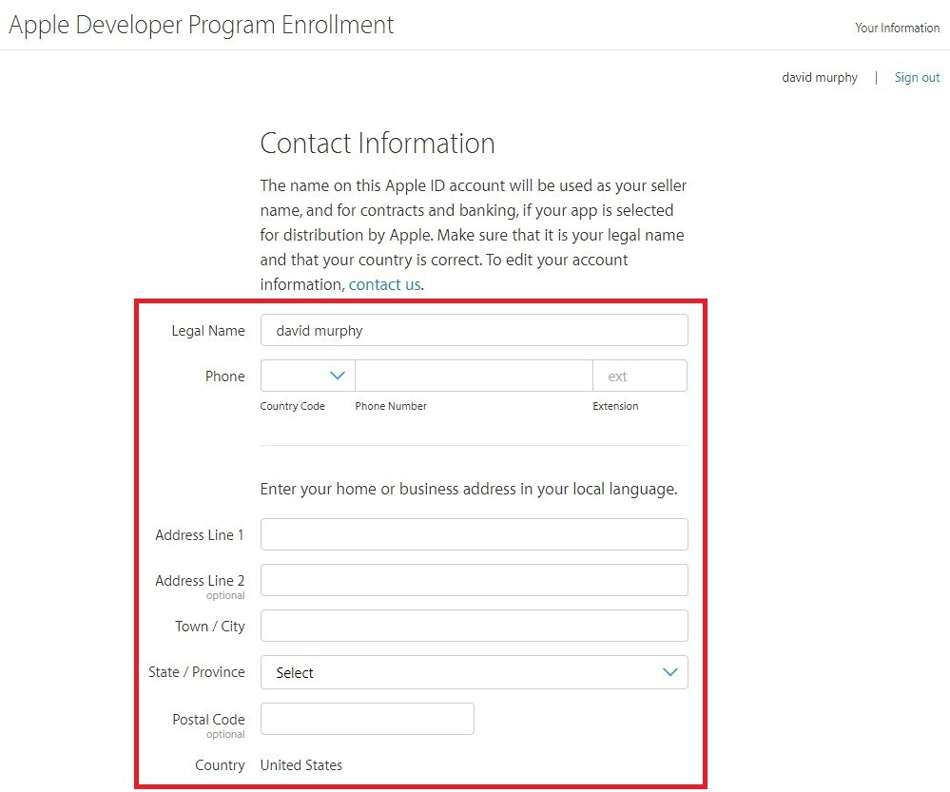

Scrolling down, read over the second terms and agreements document and click the check­box to show your approval

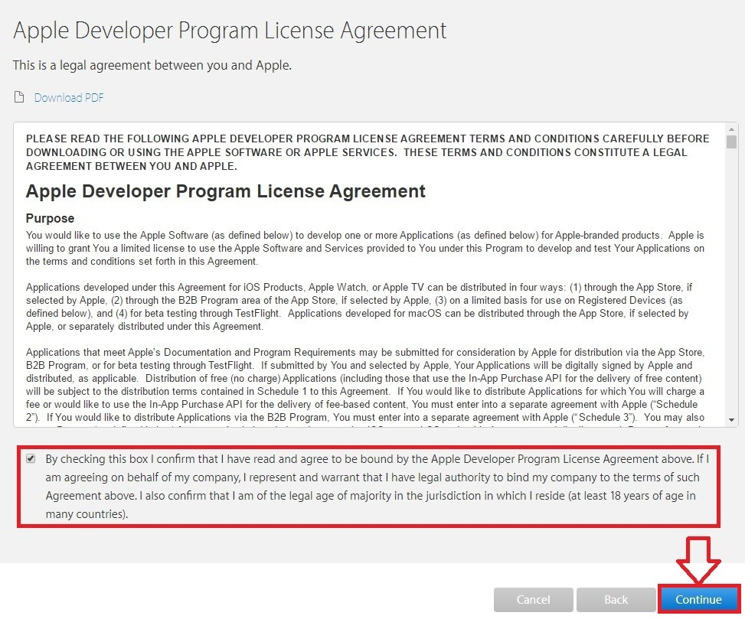

Scan through all the information on the following page to confirm that it accurately reflects your **Contact Information**

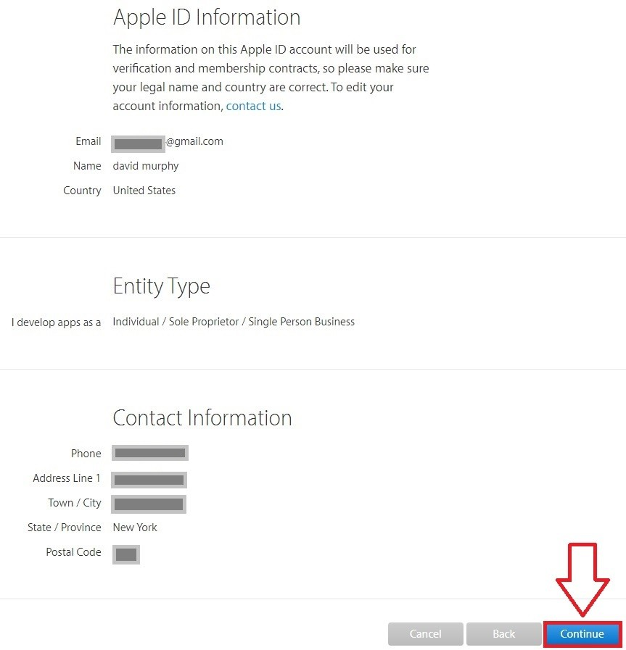

Decide whether or not you would prefer it if Apple automatically renews your membership on an annual basis. If this is your first go at app development or you’re not sure if you’ll be an app developer a year from now, then it might be best to uncheck the **Auto­ Renew** option

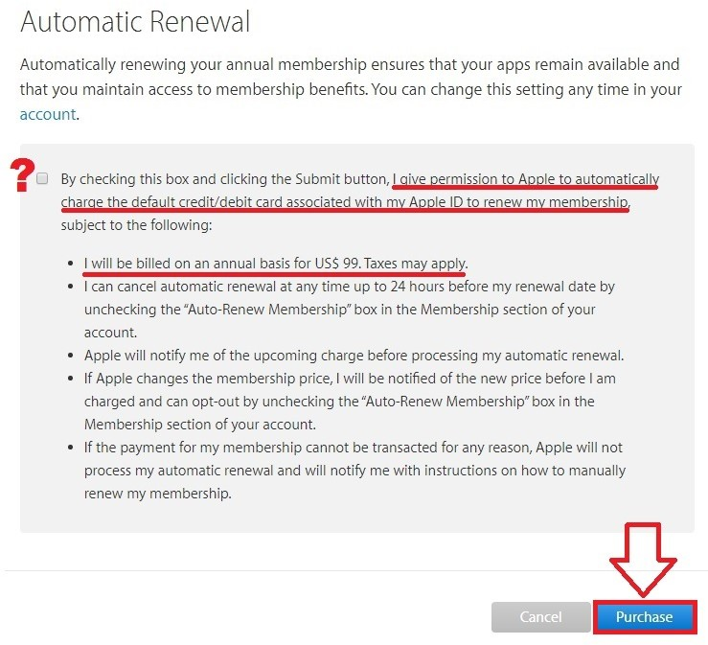

Sign in to your Apple ID again to proceed to the **Payment Options** page

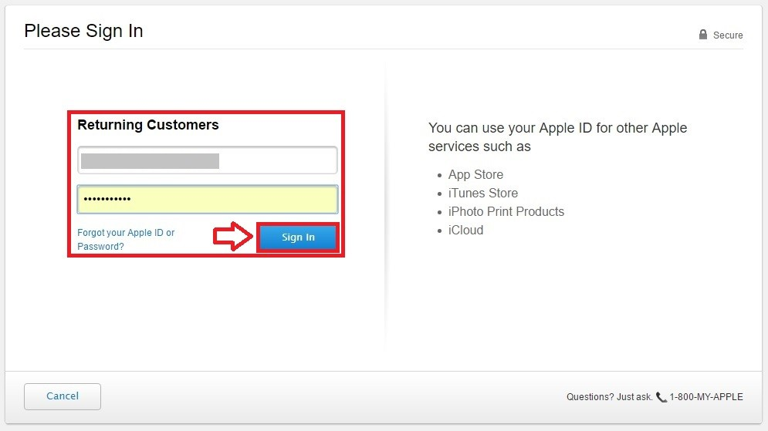

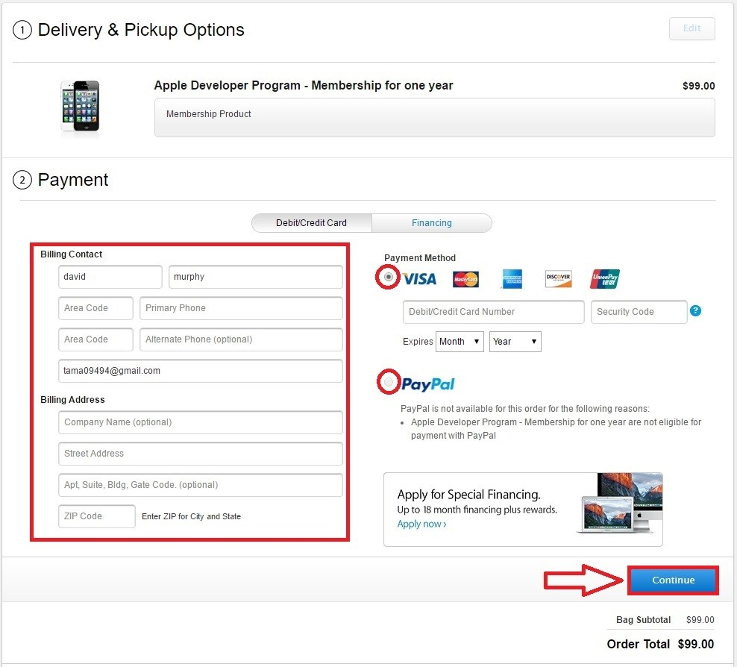

Upon completion, an email will be delivered within 24 hours with an attachment containing your activation code; using this, follow the instructions listed on the email to confirm your purchase. **Congrats! Your iOS Developer Account has been created!** If you need help developing your new idea for an app, feel free to contact us at +1­646­741­4814 anytime ­ we’d love to help!

0

You might also like this articles

Dominick Wojtas



19 December

# [“An idea of a life time comes once a month”](https://messapps.com/academy/articles/idea-life-time-comes-month/)

As many entrepreneurs will tell you, great ideas do not fall out of the sky and into your lap. An intimidating start to the app developing process is coming up with the actual idea. If pressure to make it ‘great’ from its conception is removed, then it allows for a wider velocity of ideas to surface.

0

David Murphy

11 August

# [An Intro Into TestFlight: Internal Testing](https://messapps.com/academy/an-intro-into-testflight-internal-testing-2/)

TestFlight is completely optional, yet completely free for all iOS developers

0